Task 3: High Availability + Auto Scaling
- Create an Application Load Balancer in public subnets.
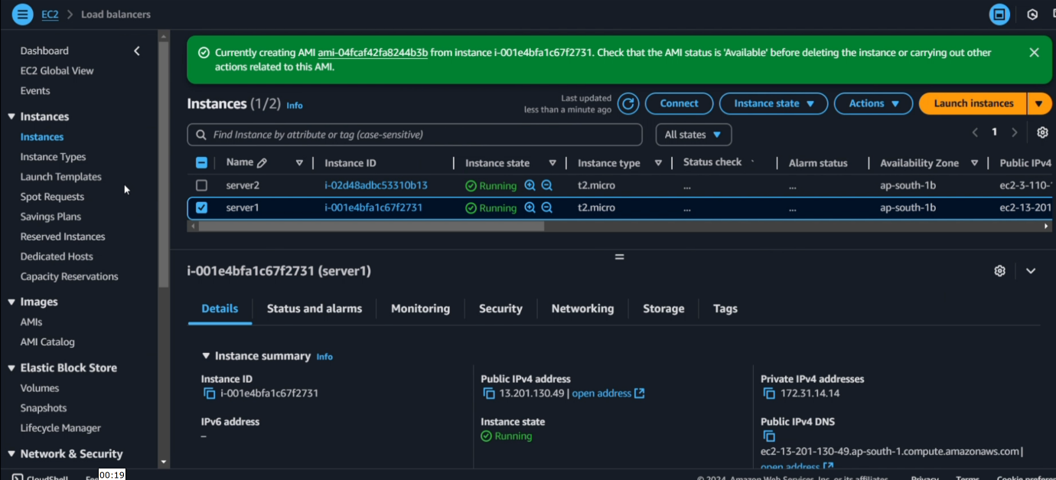
- Create Target Group for EC2 instances.
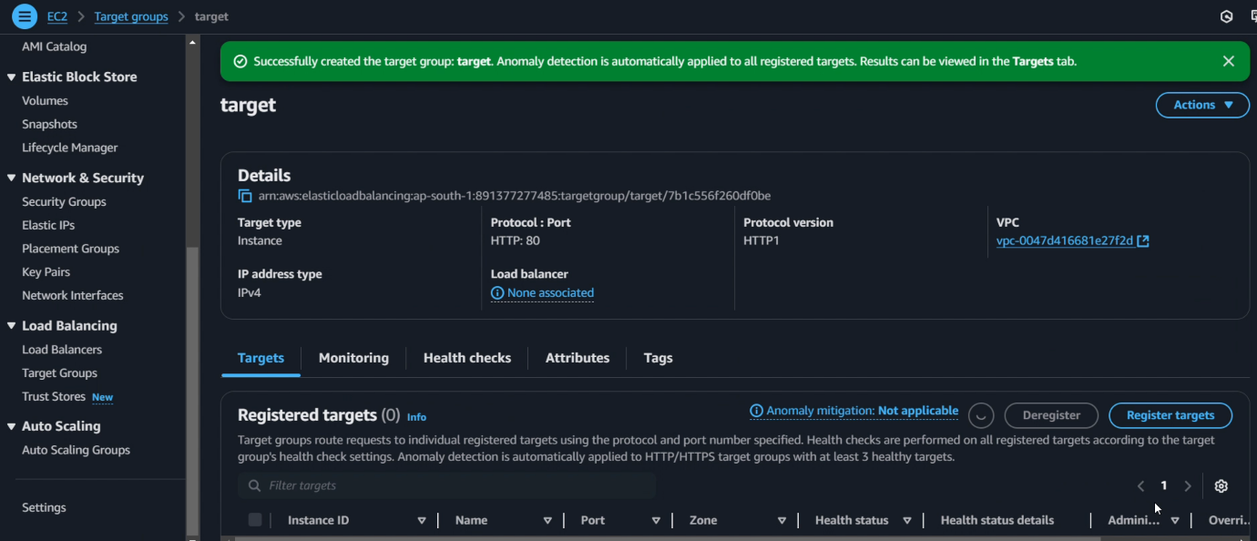
- Create Launch Template for EC2 configuration.
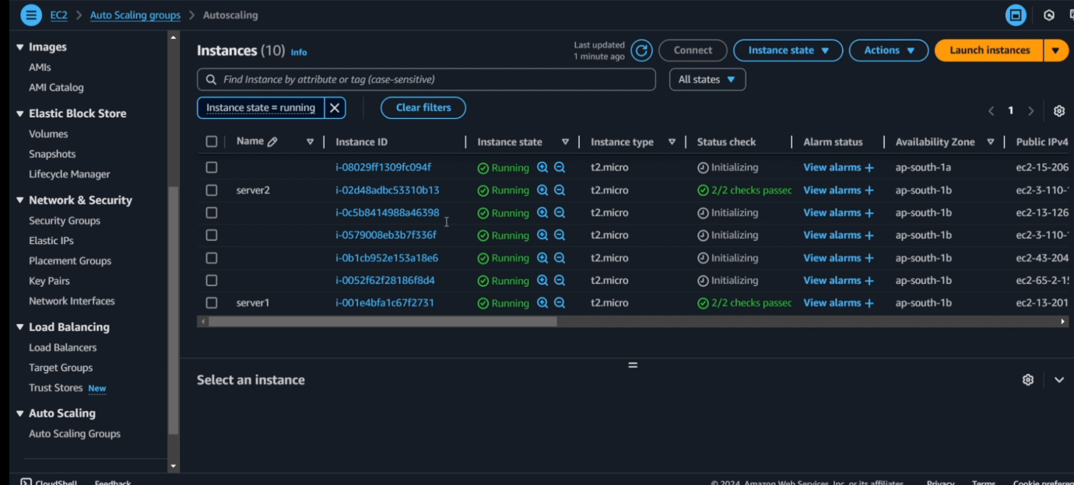
- Create Auto Scaling Group using private subnets.
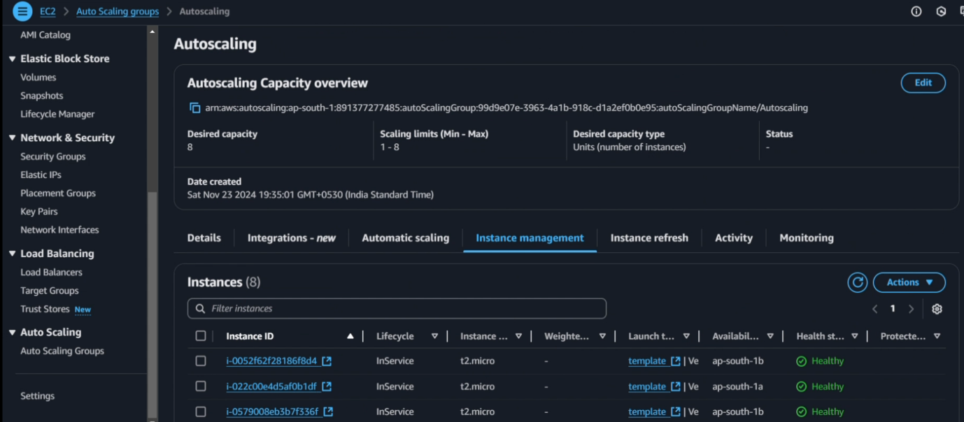
- Verify EC2 Instances created by ASG.
